1. 測試內容：

測試 Flow 之 match field:“VLAN_VID”是否正確運行。

1. 測試環境架構：

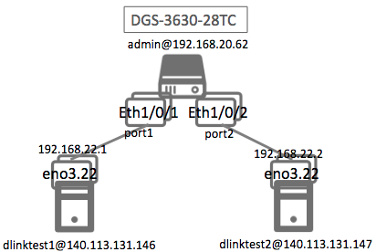

1. 測試環境組態：

* SDN controller: ONOS 1.15.0
* Switch: DGS-3630
* Hosts:
  + ubuntu 16.04.5 LTS
  + dlinktest1(實體機)
    - IP: 192.168.22.1
    - MAC: d0:94:66:5d:5e:08/64
    - Port: 1
  + dlinktest2(實體機)
    - IP: 192.168.22.2
    - MAC: d0:94:66:5c:45:20/64
    - Port: 2
* Apps:

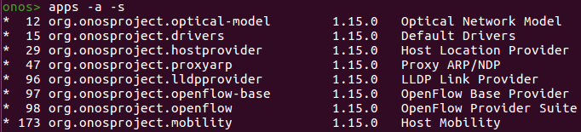

1. 測試環境架構：
2. 測試環境中將vlan tag設為22且均利用dlinktest1@140.114.131.146以及dlinktest2@140.114.131.147的eno3.22作為虛擬網卡，而實體發送的網卡則是eno3。
3. 測試環境中將vlan tag設為23且均利用dlinktest1@140.114.131.146以及dlinktest2@140.114.131.147的eno3.23作為虛擬網卡，而實體發送的網卡則是eno3。
4. 設計兩個vlan tag的原因是當vlan tag為22時，預期dlinktest1與dlinktest2可以ping通，而當vlan tag為23時，預期dlinktest1與dlinktest2無法ping通
5. 在dlinktest1@140.114.131.146中輸入以下指令：

|  |
| --- |
| $ sudo su -c 'echo "8021q" >> /etc/modules'  $ sudo vim /etc/network/interfaces |

在 /etc/network/interfaces中輸入：

|  |
| --- |
| auto eno3.22  iface eno3.22 inet static  address 192.168.22.1  netmask 255.255.255.0  vlan-raw-device eno3  auto eno3.23  iface eno3.23 inet static  address 192.168.23.1  netmask 255.255.255.0  vlan-raw-device eno3 |

1. 在dlinktest2@140.114.131.147中輸入以下指令：

|  |
| --- |
| $ sudo su -c 'echo "8021q" >> /etc/modules'  $ sudo vim /etc/network/interfaces |

在 /etc/network/interfaces中輸入：

|  |
| --- |
| auto eno3.22  iface eno3.22 inet static  address 192.168.22.2  netmask 255.255.255.0  vlan-raw-device eno3  auto eno3.23  iface eno3.23 inet static  address 192.168.23.2  netmask 255.255.255.0  vlan-raw-device eno3 |

1. 在admin@192.168.20.202中輸入以下指令：

|  |
| --- |
| Switch# configure terminal  Switch(config)# vlan 22  Switch(config-vlan)# name vlan_test  Switch(config-vlan)# exit  Switch(config)# interface eth1/0/1  Switch(config-if)# switchport mode hybrid  Switch(config-if)# switchport hybrid allowed vlan add tagged 22  Switch(config-if)# exit  Switch(config)# interface eth1/0/2  Switch(config-if)# switchport mode hybrid  Switch(config-if)# switchport hybrid allowed vlan add tagged 22  Switch(config-if)# exit  Switch(config)# exit |

1. 使用之JSON文件：

* Flow Rule: (附檔：VLAN_VID.json)
  + ETH_TYPE為必填欄位且利用IPV4_SRC來判斷該output到哪個port。
  + Match flow符合:
    - ethType = 0x0800 (即ICMP)且VLAN_VID = 22且IPV4_SRC = 192.168.22.1/32則output到port 2
    - ethType = 0x0800 (即ICMP)且VLAN_VID = 22且IPV4_SRC = 192.168.22.2/32則output到port 1

|  |
| --- |
| {  "flows": [  {  "priority": 40000,  "timeout": 0,  "isPermanent": true,  "deviceId": "of:000078321bdf4000",  "treatment": {  "instructions": [  {  "type": "OUTPUT",  "port": "2"  }  ]  },  "selector": {  "criteria": [  {  "type": "ETH_TYPE",  "ethType": "0x0800"  },  {  "type": "VLAN_VID",  "vlanId": "22"  },  {  "type": "IPV4_SRC",  "ip": "192.168.22.1/32"  }  ]  }  },  {  "priority": 40000,  "timeout": 0,  "isPermanent": true,  "deviceId": "of:000078321bdf4000",  "treatment": {  "instructions": [  {  "type": "OUTPUT",  "port": "1"  }  ]  },  "selector": {  "criteria": [  {  "type": "ETH_TYPE",  "ethType": "0x0800"  },  {  "type": "VLAN_VID",  "vlanId": "22"  },  {  "type": "IPV4_SRC",  "ip": "192.168.22.2/32"  }  ]  }  }    ]  } |

1. 測試步驟：
2. Switch GUI:

|  |
| --- |
| Switch# show vlan interface eth1/0/1-2 |

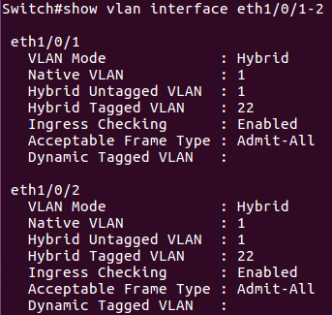

1. ONOS GUI: Flow View



1. Monitor: vlan tag為22時，預期dlinktest1與dlinktest2可以ping通

* Let h1 ping h2.

|  |
| --- |
| ping 192.168.22.2 –c 5 |

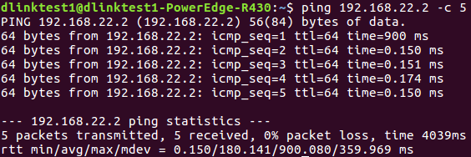

* h2 uses tcpdump to monitor.

|  |
| --- |
| sudo tcpdump –nni eno3 –e src 192.168.22.1 |

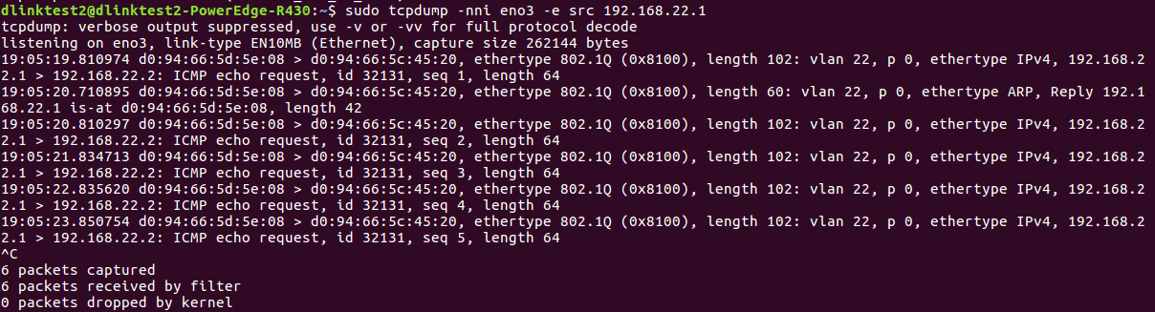

1. Monitor: vlan tag為23時，預期dlinktest1與dlinktest2無法ping通

* Let h1 ping h2.

|  |
| --- |
| ping 192.168.23.2 –c 5 |

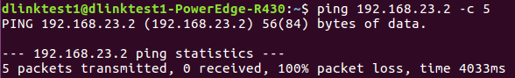

* h1 uses tcpdump to monitor.

|  |
| --- |
| sudo tcpdump –nni eno3.23 ip |

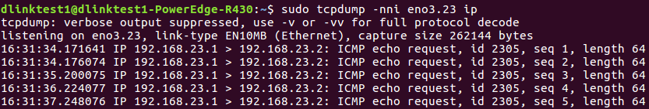

* h2 uses tcpdump to monitor.

|  |
| --- |
| sudo tcpdump –nni eno3 –e src 192.168.23.1 |

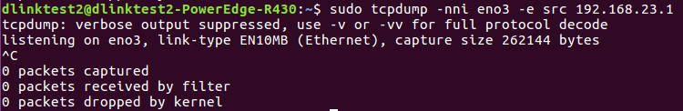

1. 測試結果：

結果符合預期，Flow之match field:“VLAN_VID”可以正確運行。